**APP ASSIGNMENT**

**Q1. EVEN/ODD CHECK**

import java.util.Scanner;

public class app {

public static void main(String[] args) {

Scanner scanner = new Scanner(System.in);

// Ask the user to enter a number

System.out.print("Enter a number: ");

int number = scanner.nextInt();

// Check if the number is even or odd

if (number % 2 == 0) {

System.out.println("The number is even.");

} else {

System.out.println("The number is odd.");

}

}

}

**OUTPUT:**

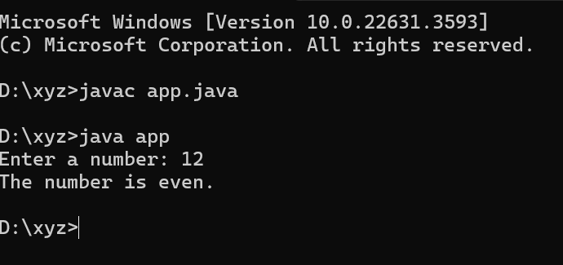

**Q2.** **AGE VERIFICATION**

import java.util.Scanner;

public class app {

public static void main(String[] args) {

Scanner scanner = new Scanner(System.in);

// Ask the user for their age

System.out.print("Enter your age: ");

int age = scanner.nextInt();

// Check if the user is eligible to vote

if (age >= 18) {

System.out.println("You are eligible to vote.");

} else {

System.out.println("You are not eligible to vote.");

}

}

**OUTPUT:**

}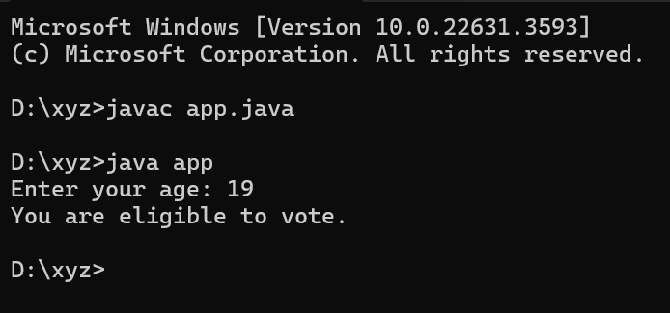

**Q3. VENDING MACHINE(SINGLE CHOICE):**

import java.util.Scanner;

public class app {

public static void main(String[] args) {

Scanner scanner = new Scanner(System.in);

// Display options for the user

System.out.println("Press 1 for juice or 2 for soda.");

int choice = scanner.nextInt();

// Check the user's choice

if (choice == 1) {

System.out.println("Dispensing juice.");

} else if (choice == 2) {

System.out.println("Dispensing soda.");

} else {

System.out.println("Invalid choice.");

}

}

}

**OUTPUT:**

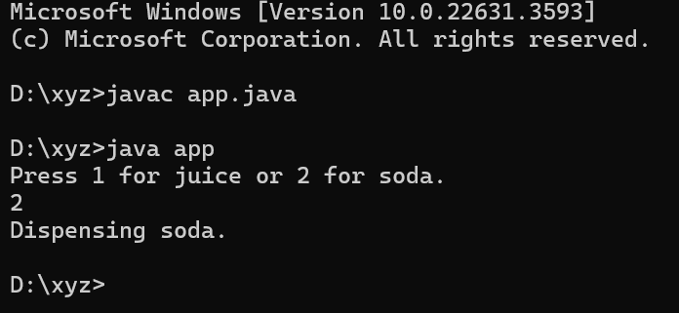

**Q4. TEMPERATURE CHECK:**

import java.util.Scanner;

public class app {

public static void main(String[] args) {

Scanner scanner = new Scanner(System.in);

// Ask the user for the current temperature

System.out.print("Enter the current temperature: ");

int temperature = scanner.nextInt();

// Categorize the temperature

if (temperature > 30) {

System.out.println("It's hot!");

} else if (temperature >= 20) {

System.out.println("It's warm.");

} else if (temperature >= 10) {

System.out.println("It's cool.");

} else {

System.out.println("It's cold.");

}

}

}

**OUTPUT:**



**Q5. POSITIVE , NEGATIVE OR ZERO:**

import java.util.Scanner;

public class app {

public static void main(String[] args) {

Scanner scanner = new Scanner(System.in);

// Ask the user to enter a number

System.out.print("Enter a number: ");

int number = scanner.nextInt();

// Check the sign of the number

if (number > 0) {

System.out.println("The number is positive.");

} else if (number < 0) {

System.out.println("The number is negative.");

} else {

System.out.println("The number is zero.");

}

}

}

**OUTPUT:**

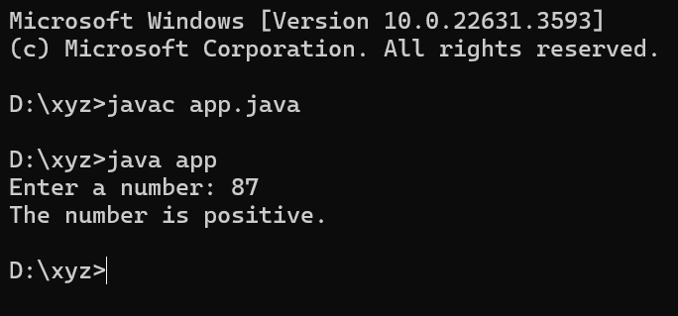

**Q6. GRADING SYSTEM:**

import java.util.Scanner;

public class app {

public static void main(String[] args) {

Scanner scanner = new Scanner(System.in);

// Ask the user for their exam score

System.out.print("Enter your exam score: ");

int score = scanner.nextInt();

// Assign a letter grade based on the score

switch (score / 10) {

case 10:

case 9:

System.out.println("A (Excellent)");

break;

case 8:

System.out.println("B (Very Good)");

break;

case 7:

System.out.println("C (Good)");

break;

case 6:

System.out.println("D (Satisfactory)");

break;

default:

if (score < 60) {

System.out.println("F (Fail)");

} else {

System.out.println("Invalid score input.");

}

break;

}

}

}

**OUTPUT:**

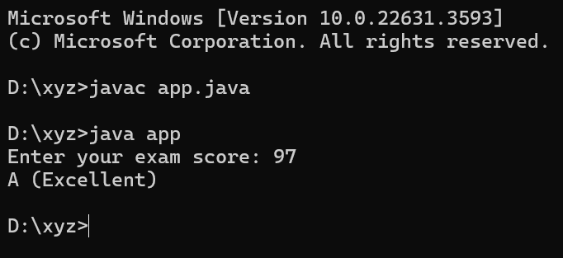

**Q7. SIMPLE CALCULATOR:**

import java.util.Scanner;

public class app {

public static void main(String[] args) {

Scanner scanner = new Scanner(System.in);

// Display the options for the user

System.out.println("Enter 1 for addition or 2 for subtraction.");

int choice = scanner.nextInt();

// Perform the chosen operation

if (choice == 1) {

System.out.print("Enter the first number: ");

int num1 = scanner.nextInt();

System.out.print("Enter the second number: ");

int num2 = scanner.nextInt();

System.out.println("The sum is: " + (num1 + num2));

} else if (choice == 2) {

System.out.print("Enter the first number: ");

int num1 = scanner.nextInt();

System.out.print("Enter the second number: ");

int num2 = scanner.nextInt();

System.out.println("The difference is: " + (num1 - num2));

} else {

System.out.println("Invalid choice.");

}

}

}

**OUTPUT:**

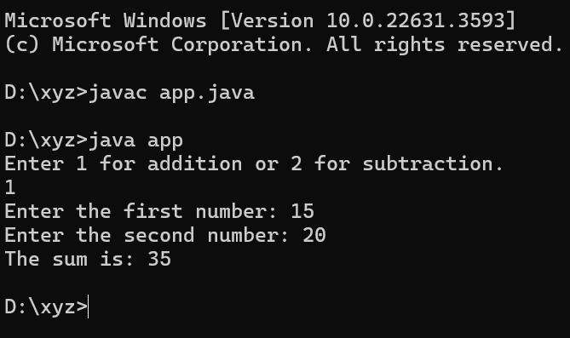

**Q8. LEAP YEAR CHECK:**

import java.util.Scanner;

public class app {

public static void main(String[] args) {

Scanner scanner = new Scanner(System.in);

// Ask the user for the year

System.out.print("Enter the year: ");

int year = scanner.nextInt();

// Check if the year is a leap year

if (year % 4 == 0) {

if (year % 100 == 0) {

if (year % 400 == 0) {

System.out.println("It's a leap year.");

} else {

System.out.println("It's not a leap year.");

}

} else {

System.out.println("It's a leap year.");

}

} else {

System.out.println("It's not a leap year.");

}

}

}

**OUTPUT:**

